.

**DeptofArtificialIntelligenceandMachineLearning**|**RajalakshmiEngineeringCollege**

137

# 08–Tuple/Set

**Ex.No. : 8.1 Date:**27/4/24

.

**DeptofArtificialIntelligenceandMachineLearning**|**RajalakshmiEngineeringCollege**

138

**RegisterNo.:231501042 Name: Dinesh Karthik K**

## BinaryString

Codershereisasimpletaskforyou,Givenstringstr.Yourtaskistocheckwhether it is a binarystring or not by usingpythonset.

Examples:

Input: str = "01010101010"Output: Yes

Input:str="REC101" Output: No

**Forexample:**

|  |  |
| --- | --- |
| **Input** | **Result** |
| 01010101010 | Yes |
| 01010110101 | No |

**PROGRAM**

str=input()

str=[x for x in str] str=set(str)

c=0

if '0' in str and '1' in str: c+=2

if(c==len(str)):

print("Yes") else:

print("No")

## Output:

.

**DeptofArtificialIntelligenceandMachineLearning**|**RajalakshmiEngineeringCollege**

139

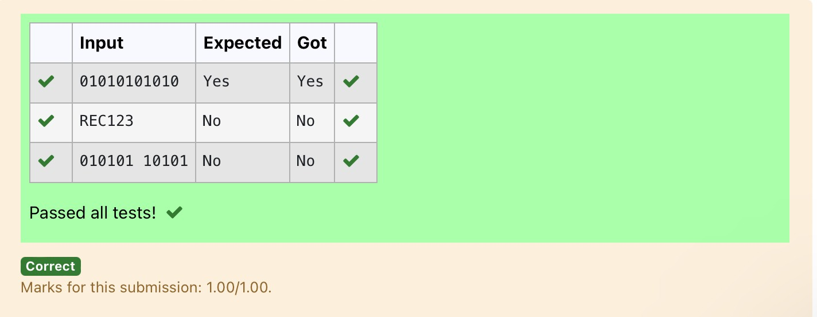

**Ex.No. : 8.2 Date:**27/4/24

**DeptofArtificialIntelligenceandMachineLearning**|**RajalakshmiEngineeringCollege**

140

**RegisterNo.:231501042 Name: Dinesh Karthik K**

# CheckPair

Givenatupleandapositiveintegerk,thetaskistofindthecountofdistinctpairsin the tuple whose sum is equal to **K**.

Examples**:**

**Input**:t=(5,6,5,7,7,8),K=13

**Output**: 2 Explanation:

PairswithsumK(=13)are{(5,8),(6,7),(6,7)}.

Therefore, distinct pairs with sum K( = 13) are { (5, 8), (6, 7) }. Therefore, the required output is 2.

Forexample:

|  |  |
| --- | --- |
| Input | Result |
| 1,2,1,2,5  3 | 1 |
| 1,2  0 | 0 |

**PROGRAM**

s=input() l1=s.split(',') n=int(input()) l2=[]

foriinrange(len(l1)): j=i+1

for j in range(len(l1)): if(int(l1[i])+int(l1[j])==n):

l2.append(list[l1[i],l1[j]]) s=set(l2)

print(len(s)//2)

.

Output:

.

**DeptofArtificialIntelligenceandMachineLearning**|**RajalakshmiEngineeringCollege**

141

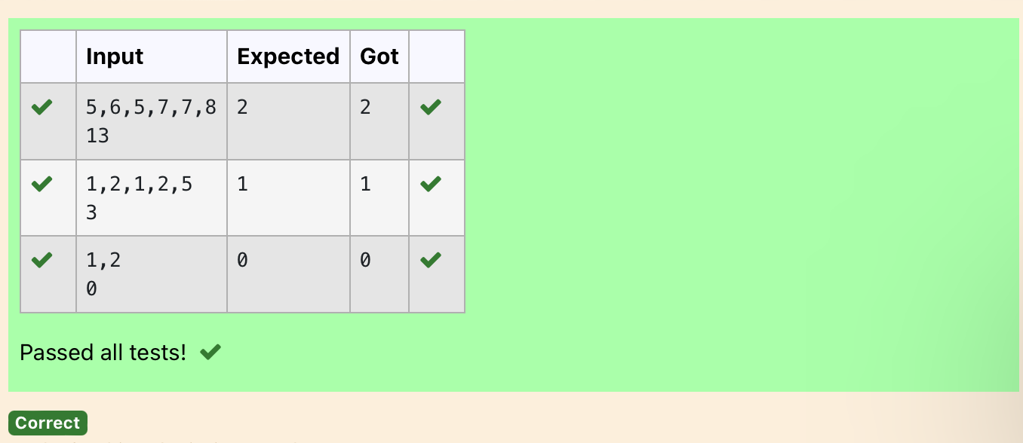

**Ex.No. : 8.3 Date:**27/4/24

**DeptofArtificialIntelligenceandMachineLearning**|**RajalakshmiEngineeringCollege**

142

**RegisterNo.:231501042 Name: Dinesh Karthik K**

## DNASequence

The**DNA sequence**is composed of a series of nucleotides abbreviated as'A','C','G', and 'T'.

Forexample, "ACGAATTCCG"isa**DNAsequence**.

Whenstudying**DNA**,itisusefultoidentifyrepeatedsequenceswithintheDNA.

Givenastringsthatrepresentsa**DNAsequence**,returnallthe**10-letter- long** sequences (substrings) that occur more than once in a DNA molecule. You may return the answer in **any order**.

**Example1:**

**Input:**s="AAAAACCCCCAAAAACCCCCCAAAAAGGGTTT"

**Output:**["AAAAACCCCC","CCCCCAAAAA"]

**Example2:**

**Input:**s="AAAAAAAAAAAAA"

**Output:**["AAAAAAAAAA"]

**Forexample:**

|  |  |
| --- | --- |
| **Input** | **Result** |
| AAAAACCCCCAAAAACCCCCCAAAAAGGGTTT | AAAAACCCCCCCCCCAAAAA |

**PROGRAM**

s = input() sequence_length = 10 seen = {}

result=[]

for i in range(len(s) - sequence_length + 1): sequence = s[i:i + sequence_length]

if sequence in seen: seen[sequence]+=1

else:

seen[sequence]=1

for sequence, count in seen.items(): if count > 1:

result.append(sequence) for i in result:

print(i)

.

**Output:**

.

**DeptofArtificialIntelligenceandMachineLearning**|**RajalakshmiEngineeringCollege**

143

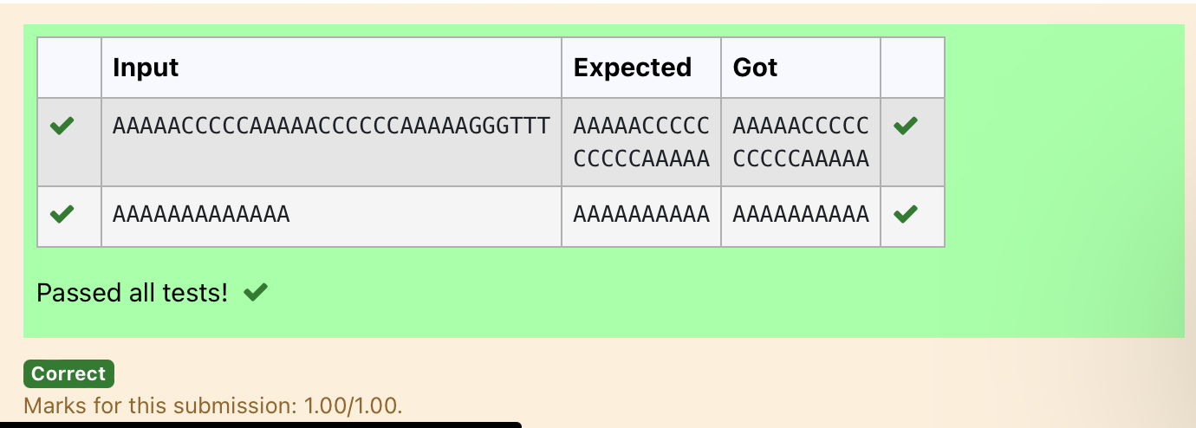

.

**DeptofArtificialIntelligenceandMachineLearning**|**RajalakshmiEngineeringCollege**

144

**Ex.No. : 8.4 Date:**27/4/24

**RegisterNo.:231501042 Name: Dinesh Karthik K**

## Printrepeatedno

Givenanarrayofintegersnums containingn+1 integerswhereeachintegerisinthe range [1,n]inclusive.Thereisonly **onerepeatednumber** in nums, return *this repeated number*. Solve the problem using [set](http://118.185.187.137/moodle/mod/resource/view.php?id=734).

### Example1:

**Input:**nums=[1,3,4,2,2]

**Output:**2

### Example2:

**Input:**nums=[3,1,3,4,2]

**Output:**3

### Forexample:

|  |  |
| --- | --- |
| **Input** | **Result** |
| 13442 | 4 |

**PROGRAM**

st=input()

nums=st.split() for i in nums:

if nums.count(i)==2: b=nums.index(i)

print(nums[b])

Output:

.

**DeptofArtificialIntelligenceandMachineLearning**|**RajalakshmiEngineeringCollege**

145

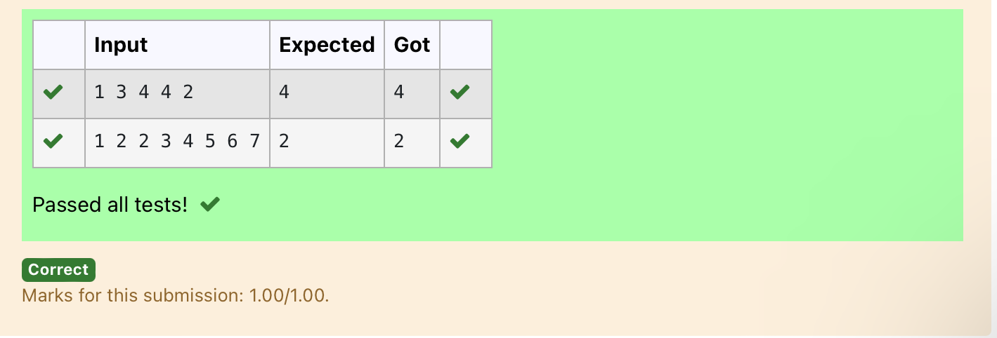

**Ex.No. : 8.5 Date:**27/4/24

**DeptofArtificialIntelligenceandMachineLearning**|**RajalakshmiEngineeringCollege**

146

**RegisterNo.:231501042 Name: Dinesh Karthik K**

## Removerepeated

Writeaprogramtoeliminatethecommonelementsinthegiven2arraysandprint only thenon-repeating elementsandthe totalnumberof suchnon-repeating elements.

InputFormat:

The first line contains space-separated values,denoting the size of the two arrays ininteger format respectively.

Thenexttwolinescontainthespace-separatedintegerarraystobecompared.

[Sample](https://www.rajalakshmicolleges.net/moodle/mod/quiz/view.php?id=5127)Input:

54

12865

26810

[Sample](https://www.rajalakshmicolleges.net/moodle/mod/quiz/view.php?id=5127)Output:

1510

3

**Forexample:**

|  |  |
| --- | --- |
| **Input** | **Result** |
| 54  12865  26810 | 1510  3 |

**PROGRAM**

sizes = list(map(int, input().split())) arr1 = list(map(int, input().split())) arr2 = list(map(int, input().split())) set1 = set(arr1)

set2 = set(arr2) unique1 = set1 - set2 unique2=set2-set1

unique_elements=list(unique1)+list(unique2)if unique_elements:

print("".join(map(str,unique_elements)))

print(len(unique_elements)) else:

print("NOSUCHELEMENTS")

.

**Output:**

.

**DeptofArtificialIntelligenceandMachineLearning**|**RajalakshmiEngineeringCollege**

147

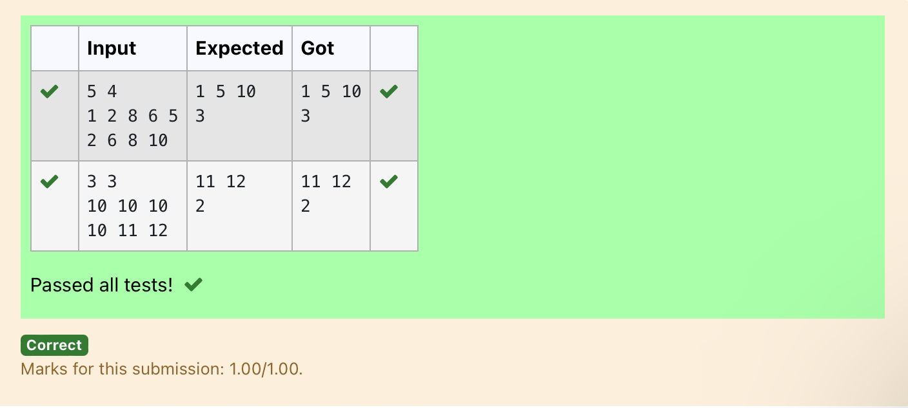

**Ex.No. : 8.6 Date:**27/4/24

**DeptofArtificialIntelligenceandMachineLearning**|**RajalakshmiEngineeringCollege**

148

**RegisterNo.:231501042 Name: Dinesh Karthik K**

## MalfunctioningKeyboard

Thereisamalfunctioningkeyboardwheresomeletterkeysdonotwork.Allother keys on the keyboard work properly.

Given a string text of words separated by a single space (no leading or trailing spaces)andastringbrokenLettersofalldistinctletterkeysthatarebroken,return the number of words in text you can fully type using this keyboard.

Example1:

Input:text="helloworld",brokenLetters="ad"Output:

1

Explanation:Wecannottype"world"becausethe'd'keyisbroken.

### Forexample:

|  |  |
| --- | --- |
| **Input** | **Result** |
| helloworld ad | 1 |

**PROGRAM**

s1=str(input()) s2=str(input()) l1=(s1.lower()).split('') l2=list(s2)

foriinl2:

forwordinl1:

if i in list(word): l1.remove(word)

print(len(l1))

.

Output:

.

**DeptofArtificialIntelligenceandMachineLearning**|**RajalakshmiEngineeringCollege**

149

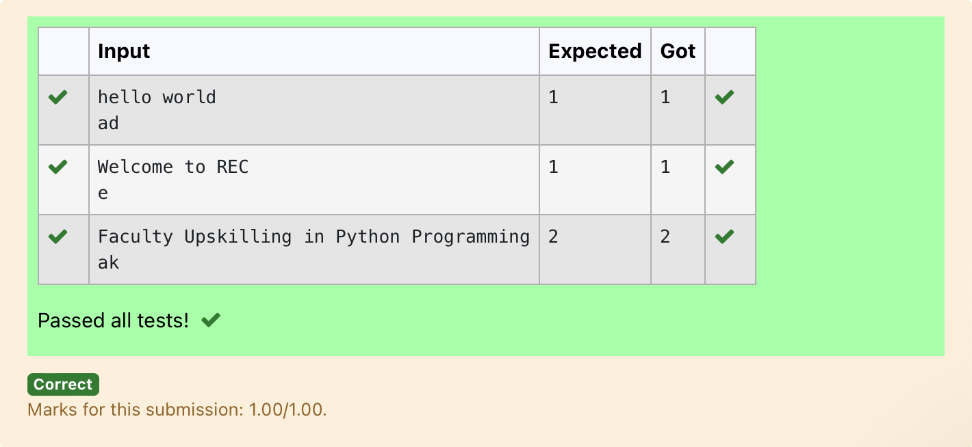

**Ex.No. : 8.7 Date:**27/4/24

.

**DeptofArtificialIntelligenceandMachineLearning**|**RajalakshmiEngineeringCollege**

150

**RegisterNo.:231501042 Name: Dinesh Karthik K**

## Americankeyboard

Givenanarrayofstringswords,return*thewordsthatcanbetypedusinglettersof thealphabetononlyonerowofAmericankeyboardliketheimagebelow*.

Inthe**Americankeyboard**:

* thefirstrowconsistsofthecharacters"qwertyuiop",
* thesecondrowconsistsofthecharacters"asdfghjkl",and
* thethirdrowconsistsofthecharacters"zxcvbnm".

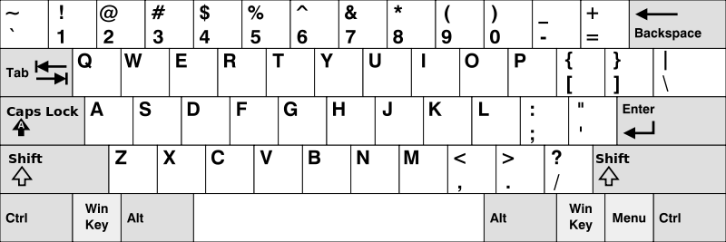

### Example1:

**Input:**words=["Hello","Alaska","Dad","Peace"]

**Output:**["Alaska","Dad"]

### Example2:

**Input:**words=["omk"]

**Output:**[]

### Example3:

**Input:**words=["adsdf","sfd"]

**Output:**["adsdf","sfd"]

### Forexample:

.

**DeptofArtificialIntelligenceandMachineLearning**|**RajalakshmiEngineeringCollege**

151

|  |  |
| --- | --- |
| **Input** | **Result** |
| 4  Hello Alaska Dad Peace | Alaska Dad |

**PROGRAM**

n=int(input()) l=[]

for j in range(n): l.append(str(input()))

row1=set("qwertyuiop") row2 = set("asdfghjkl") row3 = set("zxcvbnm") result = []

forwordinl:

lower_word =set(word.lower())

iflower_word <=row1or lower_word<=row2orlower_word<=row3: result.append(word)

if(len(result)!=0):

for iinrange(len(result)): print(result[i])

else:

print("Nowords")

Output:

.

**DeptofArtificialIntelligenceandMachineLearning**|**RajalakshmiEngineeringCollege**

152

